User Guide 10 Additional survey documents - surveyors report, abstract of field records and compiled plan sheets
Purpose of this User Guide
The purpose of this User Guide is to provide guidance to Applicant Contacts about providing supporting survey documents, such as abstract of field records, surveyors report, supplementary abstract of field records, supplementary surveyors report and compiled plan sheets through SPEAR.
Who should read this?
Primary audience: Applicant Contacts
Introduction
SPEAR provides Applicant Contacts with the ability to attach supporting survey information into an application.
Depending on the status of an application, ‘Surveyors Report’ and ‘Abstract of Field Records’ will be displayed as mandatory actions for most applications in SPEAR and must be supplied prior to an application being ‘Released for Lodgement’.
See Technical Note 4 for examples and guidelines for creating survey documents:
https://www.spear.land.vic.gov.au/spear/pages/applicants/how-do-i-set-up-my-plan-templates.shtml
NOTE: There are subtle differences between survey documents provided through SPEAR and the current paper system.
10.1 How do you add survey documents to SPEAR?
For certification applications, the surveyors report and abstract of field records can be added to SPEAR at any time after an application has been submitted to the Responsible Authority in SPEAR. They will become mandatory actions when the application reaches the status of ‘Statement of Compliance’ and must be completed before the application is released for lodgment.
Browse for and attach the previously prepared surveyors report or abstract of field records in PDF format in accordance with the requirements set out in Technical Note 04 and click ‘add now’. If the plan is based on survey, you are also required to provide survey declaration details including the date of survey and whether PCM's or PM's have been placed or located.
You will also be able to indicate if the surveyors report or abstract of field records is not required for the application.

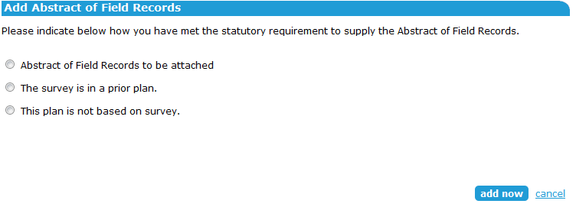

To complete this process, the document/s must then be digitally signed by a Licensed Surveyor using a digital certificate.
For all other application types (except planning permits) the actions to add a surveyors report, survey declaration and abstract of field records (if applicable) must be completed in SPEAR prior to the application being released for lodgment and subsequently lodged at LV.
10.2 Can the Advice by Licensed Surveyor (Form 13) & supplementary abstract of field records (SAFR) be submitted through SPEAR?
The Form 13 and SAFR Declaration can be optionally provided through the ‘Other Actions…’ menu when the application is in a draft state and will become mandatory before Statement of Compliance is issued unless it is deferred.
The declaration requires the Applicant Contact to indicate whether an Advice by Licensed Surveyor is required and, if applicable, provide an estimated date for the completion of works (this date can be modified if required). An option to defer is also available.
If you have previously deferred the Advice by Licensed Surveyor, it can be supplied by modifying the Form 13 and SAFR Declaration document, otherwise 30 days after the completion of works date you will be sent an email notification to supply it and a mandatory action will appear in the application.
After the ‘Add Form 13 and SAFR Declaration’ action has been completed, if a SAFR is required, it may be provided through the ‘Other Actions…’ menu. If 45 days after the completion of works date have passed, SPEAR will notify the Applicant Contact to supply the SAFR and place a mandatory action on the application.
Any outstanding requirements to supply the SAFR or Form 13 (if previously deferred) will not prevent the application from progressing through SPEAR and the document may be attached post registration of the plan. Land Use Victoria is notified when a SAFR is attached and will review the document. If changes are required to the supplied SAFR, the SPEAR requisition process applies.
Alternatively, where the Advice by Licensed Surveyor (Form 13) specifies that it is not required, the SAFR declaration will be pre-populated and immediately ready for digital signing.

10.3 Can you attach a supplementary surveyors report to support a SAFR in SPEAR?
Applicant Contacts have the optional action to ‘Add Supplementary Surveyors Report’ using
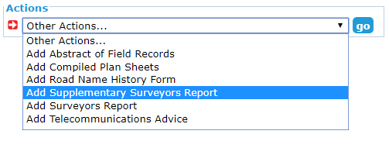
the ‘Other Actions…’ menu after a SAFR has been supplied in SPEAR.

Browse for and attach the previously prepared supplementary surveyors report in PDF format and click ‘add now’. This must be in accordance with the surveyors report requirements set out in Technical Note 04.

To complete the process, the supplementary surveyors report must be digitally signed by a Licensed Surveyor.
10.4 How do you add compiled plan sheets to SPEAR?
Compiled plan sheets can be added to SPEAR, as an optional action, at any time up until the plan is registered at Land Use Victoria.
To do this, from the Details tab, go to the ‘Other Actions’ drop-down list and select ‘Add Compiled Plan Sheets’.
Browse for and attach the previously prepared compiled plan sheets and click the ‘add now’ button.
To complete this process, the document must then be authenticated by password approval.
Need more information?
Further information on this topic can be found by:
- Visiting the SPEAR website www.spear.land.vic.gov.au/SPEAR.
- Contacting the SPEAR Service Desk on 9194 0612 or email spear.info@delwp.vic.gov.au
- Selecting the Help link in the relevant area of the SPEAR system.

